Chapter 8 Session 2 Key

- Draw the Lewis structure and determine if there is resonance:
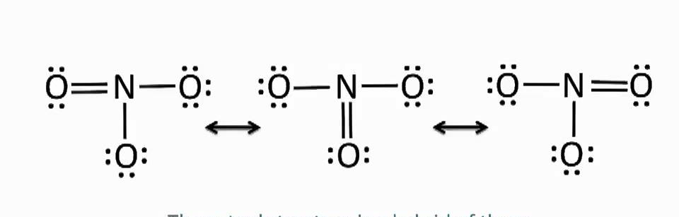
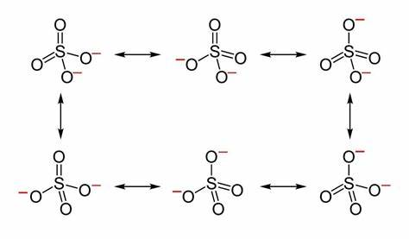

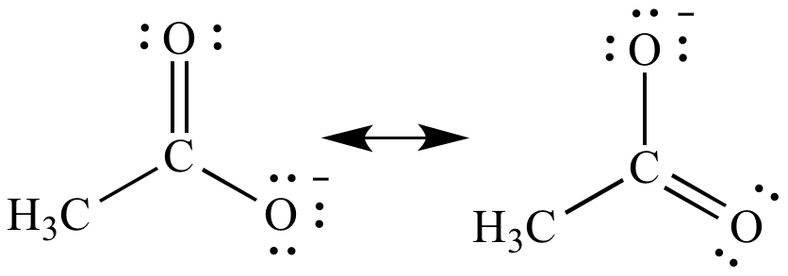

- Determine the formal charge for the Lewis Structures below and determine which is dominate:
Formal charge Valence- lone pair- ½ bonding
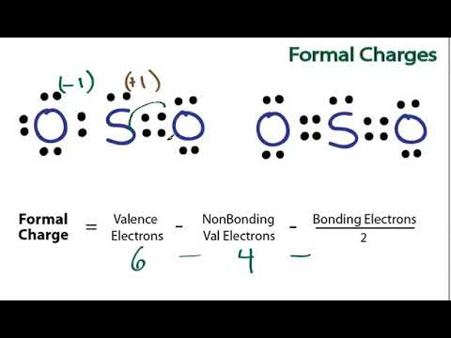

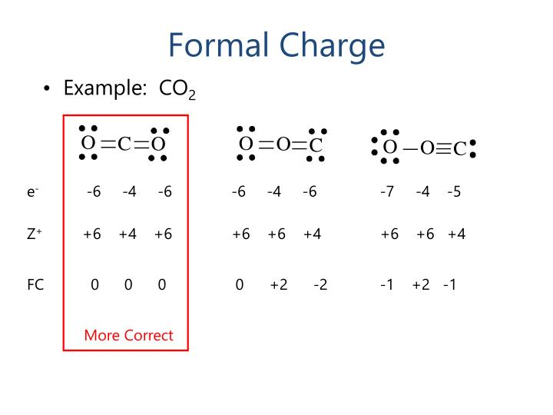

- Determine whether the compounds are polar or not and the direction of the dipoles:
